
EMPLOYEE MOTIVATION
TO ACHIEVE
- INPROCESS REJECTION TARGET (0.18%)
- ZERO QPPM.
- ZERO CUSTOMER COMPLAINT

Purpose: -
To ensure the steady implementation of own-process assurance, by complying the fundamental thought that NG parts will not be make, will not be outflow and will not be received from previous process in your own process

To promote the activity for not receiveing the NG parts from previous process, for that the operator/supplier who detect the NG from previos process, which outflow can cause severe problem in next process should be praised for his achievements.

・To improve the quality awareness and uplift the motivation of the operators and link the same with Quality improvement effort.

Applicable Parts

All the manufacturing sections & final inspection sections in the company.
(Those who are working on machines/inspection)

Eligibility Criteria

It will target all the employees of the company (including short term and contract employee also)

Proposal procedure & Route
- For Final Inspection (Q-GATE)
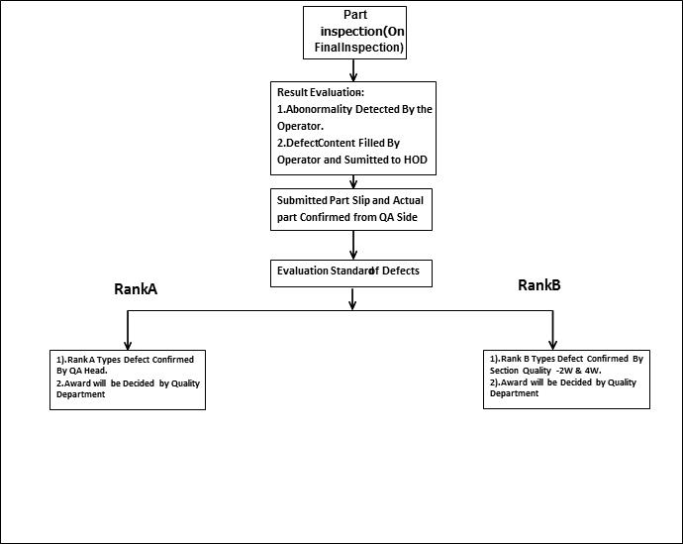

2) 2W Machining, 4W Machining and HT& Forging

One best line selected from 2W machining area, 4W machining area and HT& Forging area on
basis of Best line criteria & selected line will be awarded in RRM Meeting.

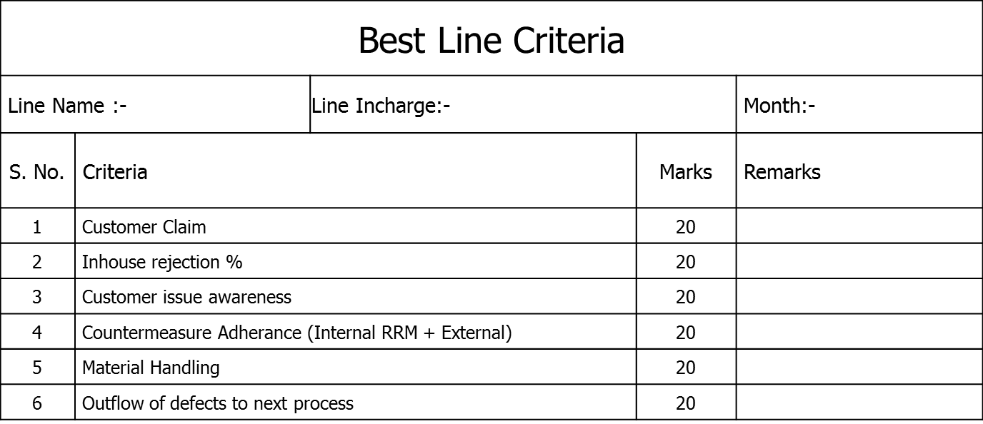
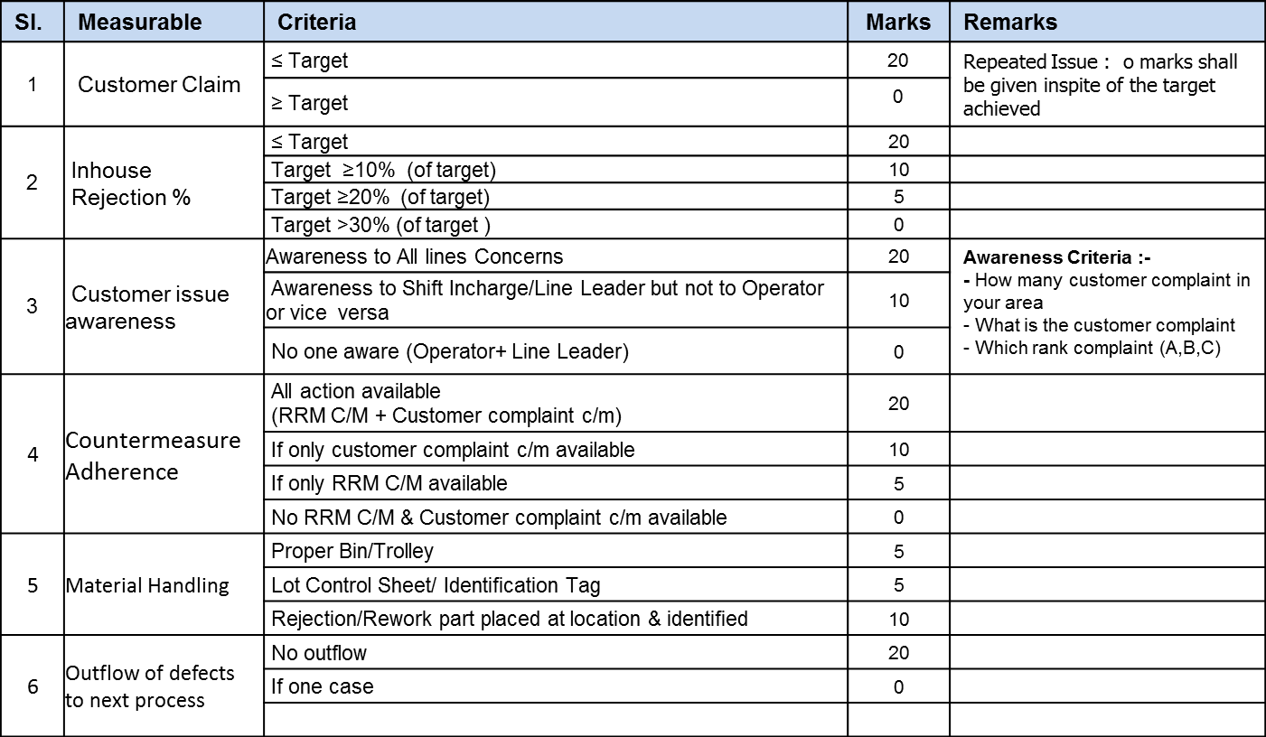

Best line audit will be conducted by the QA section heads in Last week of each month on the basis of monthly best line declaration the data shall be used to declare best line of the year
(Continuous monthly winner for best line section will be awarded with trophy for the year)

Award judging criteria

1) For Final inspection (2W Area – GRT, Assy, Cam ASSY final inspection: -

Rank A
Gift will be distributed at end of the month in Quality Meeting.

Rank B
Gift will be distributed at end of the month in Quality Meeting.

Rank C
No Gift will be considered for Rank C defects.

Note: - For Final inspection person only

2W: Assay area: If ZERO PPM from particular line /section will be awarded gift as motivation.
2W: GRT, ASSY, Cam ASSY In case of ZERO OUTFLOWS in calendar month i.e. no customer issue reported for the products (Zero PPM & Zero GQI- Global Quality Index), inspectors will be awarded gift as motivation.

2) For machining areas, HT & forging shops

- Best line gift item to all employees in that particular section which is the Awarded Best Line, the gift will be distributed at end of the month.

NOTE: - IF ANY ASSOCIATE INTENTIONALLY MISS USE THIS POLICY THEN MANAGEMENT WILL TAKE ACTION AGAINST THAT ASSOCIATE

Revision of the manual

The enactment/revision of this manual should be decided by Hod Quality after having discussion with concern departments.


ISF-QA-063

NG PART HANDOVER SLIP

Part Name: |  | Date:
Part found at: |  | Sr. No:
Defect:

Defect Rank:
Lot Number:
Quantity Found:

Remarks

Detected By Checked By Checked By Approved By
Section Head - Prod Section Head QA ( HOD QA)

Name:
Employee No:

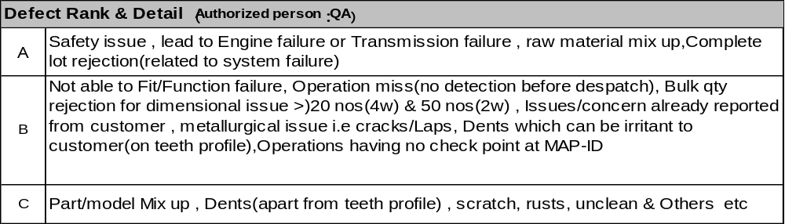

Note: The above NG slip will be provided by QA department.

PREPARED BY VERIFIED BY CHECKED BY

VIVEKANAND.S. K PANKAJ DHIMAN S. OGATA

APPROVED BY

UMASANKAR.P T. SHIRAI

ISF-QA-063

NG PART HANDOVER SLIP

Part Name: |  | Date:
Part found at: |  | Sr. No:
Defect:

Defect Rank:
Lot Number:
Quantity Found:

Remarks

Detected By Checked By Checked By Approved By
Section Head - Prod Section Head QA ( HOD QA)

Name:
Employee No:

ISF-QA-063

NG PART HANDOVER SLIP

Part Name: |  | Date:
Part found at: |  | Sr. No:
Defect:

Defect Rank:
Lot Number:
Quantity Found:

Remarks

Detected By Checked By Checked By Approved By
Section Head - Prod Section Head QA ( HOD QA)

Name:
Employee No:

